***The World Islamic Sciences and Education University***

جامعة العلوم الاسلامية العالمية

Faculty of Information Technology

كلية تكنولوجيا المعلومات



GRADUATION PROJECT

**Title**

*WISE Complaint Hub*

**Students**

Ahmad Haitham Hasan Alsemren (3220601094) CS

Abdellrahman Mohammad Ahmad Abo dya (3210601001) CS

Mahmoud Mohammad Mahmoud Alkawaja (3210605012) SCIN

**Supervisor**

Dr. Noor Al-Qudah

# **Acknowledgements**

We would like to extend our deepest gratitude to The World Islamic Sciences and Education University for its continuous support in fostering an environment that encourages academic growth and excellence. The opportunity to undertake this project would not have been possible without the resources, guidance, and opportunities provided by the university.

Our heartfelt thanks go to all the professors and academic staff who have imparted their knowledge and expertise. Their dedication to educating and shaping the minds of students has been invaluable throughout our academic journey.

We would also like to express our profound appreciation to our supervisor, Dr. Noor Al-Qudah, whose exceptional guidance and insightful comments were pivotal in shaping this project. Her mentorship has been a guiding light, directing us towards academic excellence and intellectual development.

Furthermore, we would like to extend our sincere thanks to our parents and friends, whose unwavering support, encouragement, and belief in us have been the foundation of our motivation. Their continuous faith in our potential has played a critical role in helping us reach this significant milestone in our academic journey.

To everyone who has contributed to this project, whether directly or indirectly, we express our deepest gratitude. Your collective efforts have turned our shared vision into a remarkable achievement.

May God bless and reward all of you.

المحتويات

**Acknowledgements** 2

List of abbreviations 3

**CHAPTER 1** 4

**INTRODUCTION** 4

**1.1Overview** 5

**1.2 Problem Statement** 6

**1.3 Project objectives** 7

**1.4 Research strategy (Framework)** 7

**1.5 Scope** 10

**7.1 Project outline** 12

**CHAPTER 2** 13

Figure 1: Agile Framework, 9

*Figure 2 :Agile Framework* 9

# 

# List of abbreviations

|  |  |
| --- | --- |
| **WCH** | WISE Complaint Hub |
| **WISE** | The world Islamic Science & Education University |
| **IT** | Information Technology |
| **HTML** | Hypertext Markup Language |
| **CSS** | Cascading Style Sheets |
| **JS** | Java Script |
| **SQL** | Structured Query Language |
| **UI** | User Interface |
| **ER** | Entity Relationship |
| **CS** | Computer Science |
| **SCIN** | Security and confidentiality of information and networks |

# **CHAPTER 1**

# **INTRODUCTION**

## **1.1Overview**

The primary objective of this graduation project is to develop a web-based Complaint Management System for The World Islamic Sciences and Education University, addressing the critical need for an efficient and transparent platform for handling student grievances. The system provides a centralized mechanism for submitting, tracking, and resolving institutional complaints.

Developed using ASP.NET Core, the application offers a comprehensive solution that enables users to:

* Submit complaints across multiple categories
* Track complaint status in real-time
* Maintain optional anonymity
* Receive timely updates and notifications

The technology stack includes:

* ASP.NET Core MVC
* Entity Framework Core
* SQL Server
* C#
* Bootstrap for responsive design

Key features encompass secure user authentication, automated complaint routing, role-based access control, and an analytics dashboard. The project demonstrates the practical application of .NET technologies in solving institutional communication challenges, aiming to enhance student satisfaction and university responsiveness.

By providing a structured approach to complaint management, the system transforms a complex administrative process into a streamlined, user-friendly experience that empowers students and improves institutional accountability.

## **1.2 Problem Statement**

Students at **The World Islamic Sciences and Education University** face considerable challenges when attempting to report and resolve institutional grievances. The current absence of a centralized, efficient complaint management system significantly hampers effective communication between students and administrative departments.

Without such a system, students often struggle to raise issues, track their progress, and receive meaningful resolutions.

The existing complaint-handling process is marked by several inefficiencies. First, there is no structured mechanism for submitting complaints, which leads to confusion and delays. Furthermore, there is a lack of transparency regarding the status of complaints, leaving students unaware of how their concerns are being addressed.

Communication between students and administrative departments is inconsistent, and critical feedback can be easily lost or mishandled. Additionally, there is no systematic approach to identifying and addressing recurring issues within the institution, which prevents proactive solutions from being implemented.

Students also face difficulties when reporting sensitive issues. The absence of a secure, anonymous submission process often deters them from raising concerns, particularly when confidentiality is needed. Moreover, many students find it challenging to understand the status of their complaints or to receive timely responses. The lack of an organized and transparent system results in a sense of frustration and dissatisfaction among the student body.

This unstructured approach to complaint management ultimately leads to reduced student satisfaction and diminished institutional accountability. Inefficient processes also result in unresolved issues, which, if left unaddressed, can escalate and negatively impact the overall university experience.

To resolve these pressing issues, there is an urgent need for a comprehensive, technology-driven platform that provides a secure and user-friendly complaint submission process, ensures transparent tracking of complaint resolution, and facilitates robust communication between students and the university administration. Such a system would enable data-driven insights into recurring challenges while also safeguarding student privacy and confidentiality.

## **1.3 Project objectives**

The primary objectives of this graduation project are as follows:

Develop a comprehensive web-based complaint management system for The World Islamic Sciences and Education University that provides a streamlined and transparent process for students, faculty, and staff to submit, track, and resolve complaints.

1. RO1: Design an intuitive and user-friendly interface that simplifies the complaint submission process, allowing users to easily create, view, and follow up on their complaints with minimal complexity.
2. RO2:Implement a robust user authentication and authorization system that ensures secure access to the complaint management platform while maintaining user privacy and data confidentiality.
3. RO3:Create a centralized dashboard for university administrators and management to effectively monitor, categorize, prioritize, and respond to complaints across different departments and categories.
4. RO4:Develop a mechanism for tracking complaint resolution status, providing real-time updates to complainants and enabling transparent communication between complainants and resolution teams.

## **1.4 Research strategy (Framework)**

The strategic choice of a research methodology profoundly influences the process of data collection and analysis, particularly in developing a complex system like a university complaint management platform. This section critically examines research strategies that best support the development of an effective and user-centric complaint resolution system.

In the domain of software development, the Software Development Life Cycle (SDLC) provides a traditional approach to system development. However, for a dynamic system like a university complaint management platform, a more flexible methodology is required. The rigid nature of traditional SDLC, with its sequential stages, poses significant challenges in addressing the complex and evolving needs of a complaint management system.

Agile methodology emerges as a superior approach for this project, offering the flexibility and responsiveness crucial for developing a comprehensive complaint management platform. Originating in 2001 through collaborative efforts among 17 software developers, Agile adopts an iterative approach that is particularly well-suited to projects requiring frequent adaptations and user feedback (Rikheim & Schjølberg, 2023).

Within the Agile framework, Scrum presents an optimal methodology for developing the university complaint management system. Scrum's structured yet flexible approach enables the development team to:

1. Rapidly Respond to Evolving Complaint Management Requirements: Universities have complex communication ecosystems with diverse stakeholder needs, requiring a methodology that can quickly adapt to changing requirements.
2. Facilitate Continuous Improvement: The iterative nature of Scrum allows for ongoing refinement of the complaint submission, tracking, and resolution processes based on real-world user feedback.
3. Enhance Stakeholder Collaboration: Scrum's emphasis on regular meetings and transparent communication ensures active involvement of university administrators, IT departments, and potential end-users throughout the development process.
4. Manage Complex Workflow Processes: The complaint management system involves intricate workflows, including complaint submission, categorization, escalation, and resolution tracking – all of which benefit from Scrum's structured yet flexible approach.
5. Mitigate Development Risks: By breaking the project into smaller, manageable sprints, the team can identify and address potential challenges early in the development process.
6. Ensure User-Centric Design: Regular sprint reviews and demonstrations allow for continuous user input, ensuring the system meets the actual needs of students, faculty, and staff.
7. Optimize Resource Utilization: Scrum's efficient project management approach helps control development costs while maintaining high-quality output.

The selection of Scrum for the university complaint management system project is further justified by its ability to create a transparent, accountable, and responsive development environment. This methodology empowers the development team to create a solution that not only meets technical requirements but also addresses the nuanced communication needs of a university ecosystem.

By embracing Scrum, the project aims to develop a complaint management system that is adaptable, user-friendly, and capable of evolving with the changing needs of the university community.

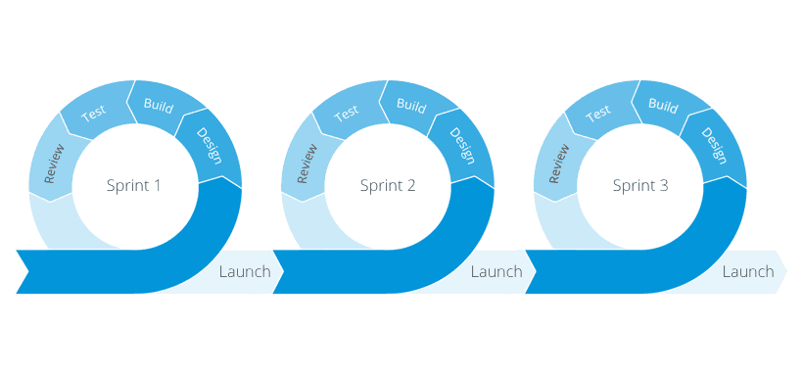

Figure : Agile Framework,

The diagram illustrates the **Agile Framework**, which is a popular methodology used in software development. It showcases three **sprints**, each representing a cycle of work that includes the following stages: **Design**, **Build**, **Test**, **Review**, and **Launch**. Each sprint begins with designing the feature or functionality, followed by the development (build) and testing phases. Afterward, the work is reviewed to ensure it meets the required standards, and finally, the feature is launched. The Agile approach emphasizes iterative development, where feedback is continuously integrated to improve the product incrementally. This cycle allows teams to deliver working software frequently, adapt to changes, and ensure that the final product aligns closely with the customer’s needs.

## **1.5 Scope**

The Complaint Management System (CMS) is a comprehensive digital platform designed for The World Islamic Sciences and Education University to streamline and enhance the complaint resolution process across the institutional ecosystem.

Core Functional Scope:

1. Complaint Submission

* Web-based complaint submission interface
* Multiple complaint categories (academic, administrative, facilities)
* Options for anonymous and identified submissions
* Secure document attachment capabilities

1. User Management

* Role-based access control
* Distinct access levels for students, faculty, and administrators
* Secure authentication mechanisms
* Comprehensive privacy protections

1. Complaint Tracking

* Unique tracking numbers for each complaint
* Real-time status updates
* Transparent complaint progression monitoring
* Automated notification system

1. Administrative Features

* Centralized management dashboard
* Complaint categorization and prioritization
* Advanced reporting and analytics
* Performance tracking and insights generation

1. Communication Tools

* Integrated messaging system
* Email and in-system notifications
* Seamless communication between complainants and resolution teams

Key Limitations:

* Exclusively for university community members
* Not a substitute for formal legal processes
* Focused on constructive institutional feedback

Strategic Objectives:

* Enhance institutional communication
* Provide structured problem-resolution mechanism
* Support data-driven institutional improvements
* Reduce communication barriers

The Complaint Management System aims to create a transparent, efficient, and user-centric approach to addressing institutional challenges at The World Islamic Sciences and Education University.

**1.6 Gantt chart**

## 

## **7.1 Project outline**

* **Chapter 2:** compares the system with other existing systems, highlighting the unique functionalities and important features in The ***WBC*** website.
* **Chapter 3:** discusses the project's approach, functional and non-functional needs, and the feasibility assessment.
* **Chapter 4**: explains the system's functionality using a series of graphs for clarity.
* **Chapter 5**: examines the implementation and evaluation of the outcomes.
* **Chapter 6**: summarizes the project idea and the future work that can be applied in the near future.

# **CHAPTER 2**

**LITERATURE REVIEW**

**2.1 Overview**

This chapter provides an overview of existing platforms designed to assist university students in submitting and managing complaints related to academic services or campus life. These platforms aim to streamline the complaint submission process, enhance complaint management, and centralize issue tracking. By offering tools that enable students to interact with the relevant university authorities, these systems improve communication, task organization, and provide effective solutions for addressing student concerns within the university environment.

The chapter also includes a comprehensive **Literature Review** that examines previous studies and research on the development of educational platforms dedicated to complaint management in universities. Relevant sources such as **Google Scholar**, **academic journals**, and other credible resources were consulted to explore best practices, challenges, and technological approaches used in similar systems.

This review aims to establish a foundation for creating an efficient, user-centric platform designed specifically to meet the needs of university students dealing with complaints related to university services.

By analyzing related works and synthesizing findings from the literature, this chapter identifies the key functionalities and features that contribute to the success of complaint management systems.

It also highlights gaps in existing solutions, providing a clear direction for the design and implementation of a tailored system that addresses the unique requirements of students at The World Islamic Sciences and Education University. This systematic approach ensures that the proposed platform will not only meet academic objectives but also offer practical benefits to its users.

**2.2 Comparative Study**

This section reviews relevant work, including academic services or student applications. The aim is to highlight previous efforts related to complaint management systems in universities. By examining existing systems, we identify key lessons and gaps that can be addressed. This comparative study helps define the factors contributing to the success of these systems, guiding the development of a solution tailored to the needs of students at **The World Islamic Sciences and Education University**.

**2.2.1 Related Work**

* [**Complaint Board**](https://www.complaintsboard.com/new_complaint/)

Complaint Board is an online platform designed to allow consumers to file complaints against companies, products, or services.

It acts as a forum where users can share their grievances publicly, and other users can comment or provide feedback on these complaints.

This platform allows consumers to voice their issues, seeking resolutions from companies or relevant authorities.

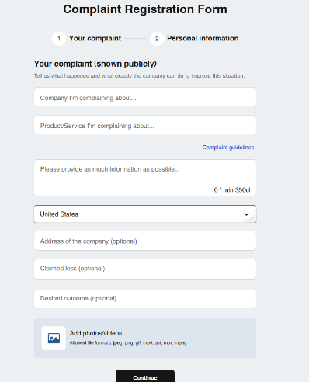Purpose: To provide a platform for consumers to share their complaints and receive feedback from other users or company representatives, with the goal of resolving consumer issues and improving services.

* **Consumer Protection**

Consumer Protection is a government-established platform that helps consumers address grievances related to products and services.

It provides tools for filing complaints and connects consumers with the appropriate authorities or companies to resolve issues.

The platform works to ensure that consumers’ rights are upheld and that they receive fair treatment in cases of faulty or unsafe products.

**Purpose**: To protect consumers' rights by offering a tool for filing complaints against businesses, ensuring that companies follow safety and quality standards while providing fair solutions to consumer issues.

* [**WISE University Suggestions and Complaints Platform**](https://www.wise.edu.jo/%D8%A7%D9%84%D8%A5%D9%82%D8%AA%D8%B1%D8%A7%D8%AD%D8%A7%D8%AA-%D9%88%D8%A7%D9%84%D8%B4%D9%83%D8%A7%D9%88%D9%89/)

This is an online platform for students and staff to submit complaints and suggestions to improve university services. It helps the university listen to feedback and solve problems effectively.

**Purpose:**  
To collect and address complaints and suggestions to enhance education quality and services.

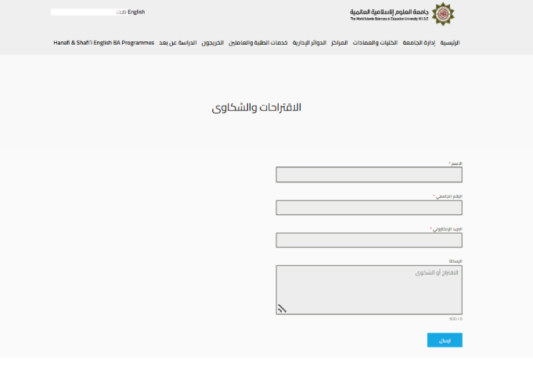

* **WCH**

The Complaint Management System is designed to help university students efficiently submit and manage their complaints related to academic or campus services. This system addresses one of the biggest challenges for students: submitting complaints in a structured and accessible manner. Initially, the system will be limited to a specific set of services, but over time, it will be expanded to cover more areas and include all university services.

The system provides several features that were not addressed in previous platforms, although not all features will be available at the same time or within the same platform, such as:

Complaint Submission: Enabling students to easily submit their complaints online, ensuring a clear categorization of issues related to services, facilities, and academic concerns.

Supervision and Management: Helping university staff and administrators track and manage the complaints to ensure timely resolutions and proper management according to university policies.

**2.3 Summary**

The absence of an efficient system for submitting and managing student complaints presents a significant challenge for both students and university staff.

The proposed Complaint Management System simplifies this process by providing students with an easy-to-use platform to submit complaints related to academic or campus services.

Students can categorize their issues, ensuring a clear and structured submission. The system also allows for tracking the status of complaints in real-time and ensures prompt feedback from relevant departments.

University staff and administrators can oversee the complaint resolution process, ensuring that students’ issues are addressed in a timely and organized manner.

Additionally, the system provides the ability to monitor trends in student complaints, which helps improve services and campus facilities. Unlike other systems, this platform ensures a streamlined, user-centric experience with complete integration into university policies and procedures, ensuring both academic integrity and operational transparency.

|  |  |  |  |  |
| --- | --- | --- | --- | --- |
| Feature/Aspect |  |  |  |  |
| Allows supervisor tracking and support | Yes | No | No | No |
| Email notifications | Yes | Yes | Yes | No |
| Categorizes complaints into different types | Yes | No | No | No |
| Provides reports and analytics for complaints | Yes | No | No | No |
| Ensures data security and privacy | Yes | Yes | Yes | Yes |

**In addition to that, this chapter highlights some of the existing platforms that have been already implemented in other universities, it demonstrates how these systems provide enhanced solutions for the problems noted.**

**CHAPTER 3**

**METHODOLOGY**

**3.1 Overview**

This chapter provides a detailed exploration of the comprehensive feasibility study, the methodology employed in the project, as well as the functional and non-functional requirements.

**3.2 Feasibility study**

The primary objective of a feasibility study is to evaluate the economic viability of a proposed business or project. The outcome of the study determines whether it is advisable to proceed with the proposed venture. If the feasibility study yields positive results, the next step is to develop a comprehensive business plan. However, if the findings indicate that the project is not a viable business idea, it should not be pursued. While it may be challenging to accept unfavorable results, identifying potential issues early in the process is far more beneficial than discovering them at a later stage.

**3.2. Technical feasibility**

A technical feasibility study reviews the technical resources available for the project, which determines if the right equipment, enough equipment, and the right technical knowledge are provided to complete this project's objectives.

*Table 1:Real life cost for Uni*

|  |  |
| --- | --- |
| Item | Estimated cost |
| Courses | 100 JD |
| Meeting | 50 JD |
| Other expenses | 50 JD |
| Total | 200 JD |

**3.2.2 Operational feasibility**

An operational feasibility study evaluates whether the organization can complete this project or not. This includes staffing requirements, organizational structure, and any applicable legal requirements. At the end of the operational feasibility study, your team will have a sense of whether you have the resources, skills, and competencies to complete this work.

*Table 2:Operational Feasibility*

|  |  |
| --- | --- |
| Process | Percentage |
| Readiness and Training | 85% |
| Maintenance Viability | 75% |
| Workflow Efficiency | 70% |
| Performance | 80% |
| Process Integration | 80% |

**3.3 Requirements**

**3.3.1 Type Collected**

**3.3.1.1 Interview:**

Interviews were conducted with students, faculty, and administrative staff as part of the requirements gathering process to develop the university complaint management system. During these interviews, the team aimed to understand users’ needs and expectations from the system, focusing on important features and how the system could effectively manage complaints. Guided questions explored how users currently handle complaints and the challenges they face in submitting and resolving them. They also shared their opinions on the user interface and personal preferences for system design. These interviews played a crucial role in guiding development to better meet user expectations and ensure a satisfactory and efficient user experience. (Rezzky, 2021)

**3.3.1 Types of Requirements:**

**3.3.1.1 Functional Requirements:**

These describe the specific services and functions the complaint management system should provide, including how it should respond to user actions and inputs. Functional requirements may also specify what the system should not do to ensure proper operation.

|  |  |
| --- | --- |
| **Requirement** | **Description** |
| User Login | The system must allow users to log in using their credentials. |
| Profile Management | Users must be able to view, and edit their profiles, including skills and project preferences. |
| Team Creation | Users must be able to create teams, specifying project type, skills required, and programming languages. |
| Team Browsing | Users must be able to browse existing teams based on filters such as project type, and languages. |
| Join Requests | The system must allow students to send a request to join teams. |
| Add Requests | The system must allow team leader to send a request to add students to his team. |
| Admin Panel | Administrator must be able to monitor and manage teams, delete teams, accept/reject teams creation requests and members exit/expulsion requests. |
| Notifications | The system must notify users of important actions, such as join requests and requests to refuse to establish a team. |
| Search for a student | The system must allow students to search for a student using students name or ID. |
| Search for a team | The system must allow students to search for a team using team name. |
| Edit team info | The system must allow team leader to edit team info. |
| Edit deadline | The system must allow administrator to edit the deadline. |

**3.3.1.2 Non-functional Requirements**

There are constraints on the services or functions offered by the university complaint management system. These include timing constraints that the system must meet for quick response, constraints on the development process to ensure compatibility with the university environment, and constraints imposed by standards related to data protection and privacy. Non-functional requirements usually apply to the system as a whole rather than individual features or services.

|  |  |
| --- | --- |
| **Requirement** | **Description** |
| Usability | The system must have a user-friendly interface, ensuring ease of navigation and interaction. |
| Performance | The platform must handle up to a specified number of concurrent users without performance degradation. |
| Scalability | The system must be designed to accommodate additional users and features in the future. |
| Security | User data must be securely stored. |
| Availability | The platform must maintain a high level of uptime, ensuring reliability for users. |
| Compatibility | The application must be accessible across modern web browsers and devices. |
| Maintainability | The system must be developed using modular code to facilitate future updates and bug fixes. |

3.4 Tools

* Office365.
* Visual Studio 2022.
* Draw io , ERPlus.
* **Language**: HTML, CSS, JS, Bootstrap, Asp.Net Core, Sql Server Management Studio.
* **AI**: ChatGPT, GitHub Copilot.
* **Web-Browser**: Google chrome / Brave.
* **Hardware**: laptop

**3.5 Methodology Process**

Scrum is one of the most popular software development methodologies. It deals with many environmental and technical variables, such as requirements and resources, which can change during the development process. This can make the process unpredictable and complex if not managed properly. Therefore, the **WCH** system requires flexibility in its development process to quickly and effectively adapt to these changes.

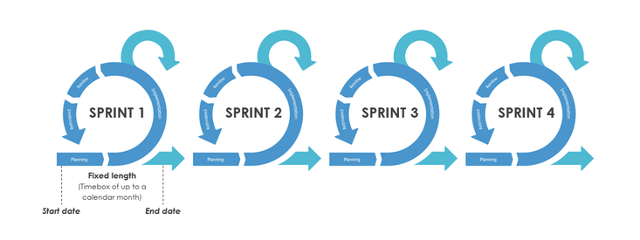Additionally, Scrum helps improve engineering practices within the team by involving frequent management activities aimed at identifying any problems or obstacles in the development process and the practices used. The **WCH** system is developed using Scrum because it is one of the most widely used and trusted frameworks in the software industry. It offers easy scalability, flexibility to changes, improved software quality, and helps reduce risks during development.

**Main Roles in Scrum**

* **Scrum Master**  
  Responsible for facilitating the Scrum process and ensuring the team follows the methodology correctly.
* **Product Owner**  
  Responsible for defining project requirements and prioritizing the work.
* **Scrum Team**  
  The development team that executes the work and collaborates to achieve project goals.
* **Customer**  
  The user or stakeholder who benefits from the final product and provides feedback.
* **Management**  
  The management team that supports the Scrum team by providing resources and guidance.

**Sprints**

A sprint is an iterative development cycle during which system functionalities are developed or improved to produce a new updated increment of the system. Each sprint goes through the traditional software development phases: requirements gathering, analysis, design, development, and delivery. During the sprint, the system’s architecture and design gradually evolve as new features are added or existing ones are enhanced.

A sprint typically lasts from one week to one month and is planned in advance. In some cases, more than one team may work simultaneously on building the increment.

|  |  |  |  |
| --- | --- | --- | --- |
| **Sprints** | **Objectives** | **Tasks** | **Deliverables** |
| Sprint 1  2 Weeks | 1- Identify and understand the problems faced by students when submitting and managing complaints.   |  | | --- | | 2- Gather and analyze user requirements for the system. |  |  | | --- | |  | | |  | | --- | | 1- Conduct interviews with students to understand challenges and needs. |  |  | | --- | |  |  |  | | --- | | 2- Review existing complaint management systems and best practices in other universities. |  |  | | --- | |  |  |  | | --- | | 3- Create initial system diagrams such as Use Case diagrams and Data Flow Diagrams (DFDs). |  |  | | --- | |  | | |  | | --- | | 1- Problem statement and system requirements. |  |  | | --- | |  |  |  | | --- | | 2- List of functional and non-functional requirements. |  |  | | --- | |  | |
| Sprint 2  5 Weeks | 1- Design the overall architecture and structure of the complaint management platform.  2-Select the most appropriate technologies for developing the project, ensuring they meet the university’s requirements. | 1-Create detailed Entity-Relationship Diagram (ERD) to define the database structure.  2-Design the user interface (UI) and user experience (UX) mockups for key features like registration, login, and team management.  3-Choose the technology stack:  **a-Frontend**: HTML, CSS, JavaScript.  **b-Backend**: Node.js and Express.js.  **c-Database**: PostgreSQL.  4-Set up the development environment, including a localhost server for testing. | 1-Finalized system design (ERD, UI/UX mockups).  2-Configured development environment. |

**CHAPTER 4**

**DESIGN MODELS**

**4.1 Overview**

This chapter presents the design models for the WISE Complaint Hub system, a web-based complaint management platform designed for The World Islamic Sciences and Education University. The system aims to provide a secure, transparent, and efficient platform for students and university staff to submit, manage, and resolve institutional complaints. The design models in this chapter include the **Context Diagram, Data Flow Diagram (DFD),** **Use Case Diagram**, **Entity-Relationship (ER) Diagram**, and **Relational Model.** These models are essential for understanding the system’s architecture, the flow of information between users and system components, user interactions with various system functionalities, and the underlying database structure that supports data storage and retrieval. Each model provides a unique perspective on the system, ensuring a comprehensive understanding of its design and functionality.

**4.2 Context diagram-0**

Provides a high-level view of the WISE Complaint Hub system, illustrating the interaction between external entities (students, university staff, and administrators) and the system in Figure 4.1. This diagram outlines the main system boundaries, highlighting how users interact with the complaint management platform to submit complaints, track their status, and receive feedback from the university's resolution team.

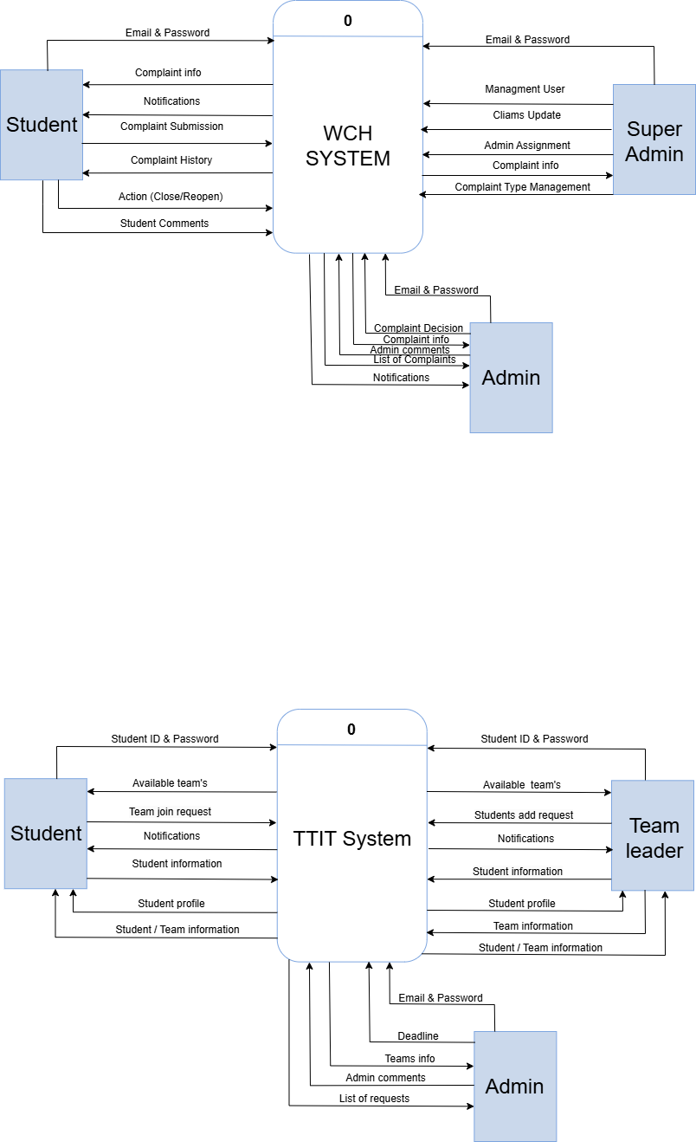

Figure 4.1: Context diagram-0

**4.3 Data flow Diagram-1**

Depicts the main processes within the **WISE Complaint Hub** system and the flow of data between these processes and external entities in **Figure 4.2.** The diagram illustrates how complaints are submitted by students, processed by the system, and managed by university administrators, ensuring a seamless flow of information for complaint resolution.

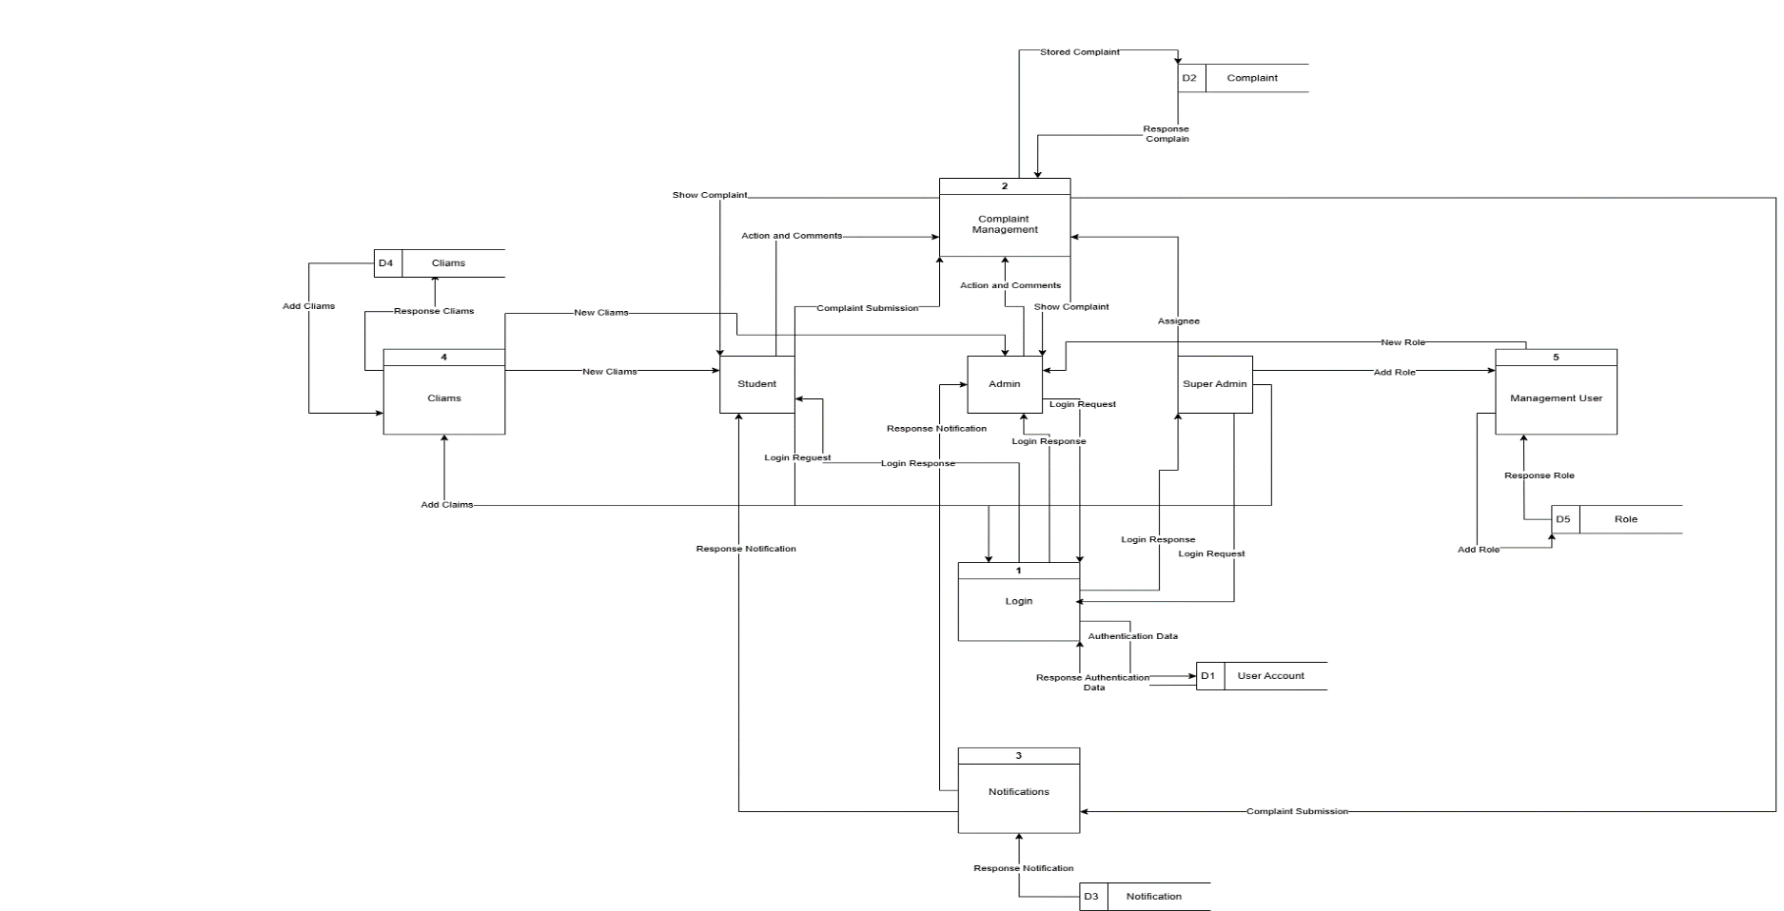

*Figure 4.2:* Data flow Diagram-1

**4.4 Use Case Diagram**

The **Use Case Diagram** for the **WISE Complaint Hub** system is shown in **Figure 4.3**. It illustrates the main interactions between the system and users, highlighting key functionalities such as complaint submission, tracking, notifications, and role management.

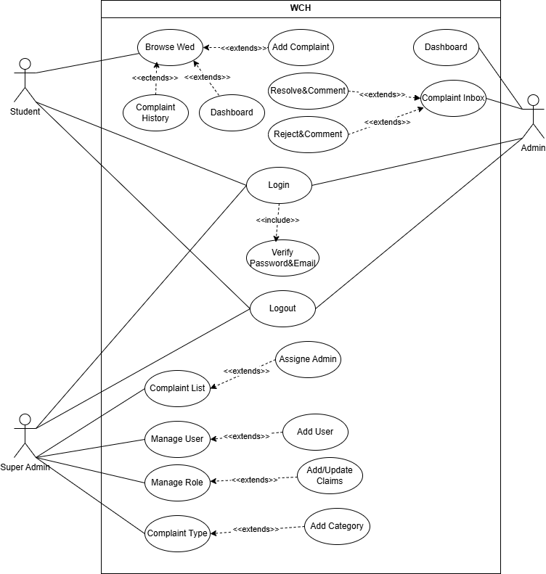

Figure 4.3: Use Case Diagram

**4.5 ER Diagram**

The **ER Diagram** in **Figure 4.4** illustrates the data entities, their attributes, and relationships within the **WISE Complaint Hub** database. It shows how data such as user accounts, complaints, notifications, and roles are structured and connected.

**4.6 Relational Model**

The Relational Model defines how the entities in the WISE Complaint Hub system are represented as tables in the relational database. It outlines the structure of each table, including fields, primary keys, and foreign key relationships, ensuring logical data organization and integrity. Key tables include Users (with UserID as primary key), Complaints (linked to Users via UserID), Notifications, and Roles. This model supports efficient data management and enforces consistent relationships within the system. Shown in **Figure 4.5.**

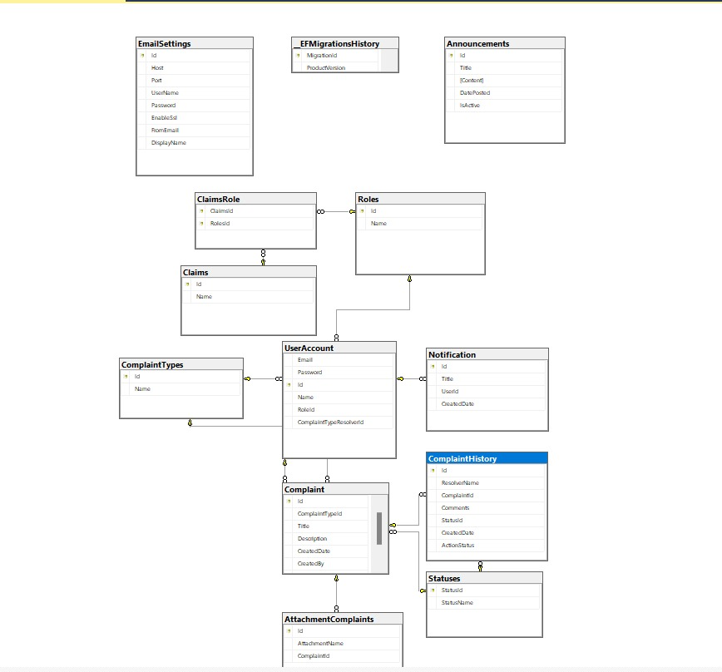

Figure 4.5: Relational model

**CHAPTER 5**

**EXPERIMENTS AND RESULTS**

5.1 Overview

5.2 Testing methodologies

5.2.1 Unit Testing Results

5.2.2 Integration Testing Results

5.2.3 System Testing Results

5.2.4 Acceptance System Results

5.3 Discussion and evaluation

**CHAPTER 6**

**CONCLUSION AND FUTURE WORKS**

6.1 Overview

6.2 Summary about the project

6.3 Achieved objectives

6.4 Main contributions of the work

6.5 Limitation

6.6 Future Work

REFERENCES

Rikheim, A. S., & Schjølberg, E. H. (2023). The use of Agile practices in regulatory evoked development: A case study of a large-scale inter-company project in the financial industry. *Master's thesis, NTNU*.

Appendices [if any]

**تعليمات هامة**

1. يرجى الالتزام التام بالتسلسل المبين في الاعلى.
2. حجم الخط المستخدم في التوثيق هو 12 ونوع الخط هو Times New Roman.
3. حجم الخط المستخدم في اسم الوحدة هو 20 ونوع الخط هو Times New Roman والمحاذاة هي توسيط وغامق.
4. حجم الخط المستخدم في العناوين الفرعية هو 16 ونوع الخط هو Times New Roman.
5. الترقيم المستخدم في الصفحات الاولى هو الترقيم اللاتيني.
6. الترقيم يبدأ من الوحدة الاولى ويستخدم ترقيم عادي 1,2,3,4 في وسط الورقة.
7. ينتهي الترقيم مع نهاية المراجع.
8. يتم اضافة Codes و صور من الشاشات Print Screen و عينات من جمع البيانات بعد ال Appendix.
9. يتم تسليم نسخ Spiral الى المشرف عدد 4 والبرمجيات عدد4 الى المشرف في نهاية الفصل.
10. بعد اجراء التعديلات النهائية يتم تسليم نسخة مغلفة بنفس الصفحة الاولى وباللون الاصفر.
11. حجم الخط المستخدم للصفحات الاولى هو 18 ونوع الخط هو Times New Roman والمحاذاة هي توسيط وغامق.
12. حجم الخط المستخدم للكلمات References and Appendix هو 14 ونوع الخط هو Times New Roman والمحاذاة هي يسار.
13. اضافة المراجع المستخدمة في ال References باستخدام نظام [1],[2]….. مع التسلسل في الاستخدام.